C29PE Tutorial 4 Questions – Market Structures

- To which of the above four categories do the following apply to the member firms? (There can be more than one market category in each case.)
  - Firms face a downward sloping demand curve.
  - New firms can freely enter the industry
  - Firms produce a homogeneous produc

  - Firms are price takers
  - Firms face an elastic demand (but less than infinity) at the profit-maximising output.

  - Firms will produce where MR = MC if they wish to maximise profits.
  - There is perfect knowledge on the part of consumers of price and product quality.

- 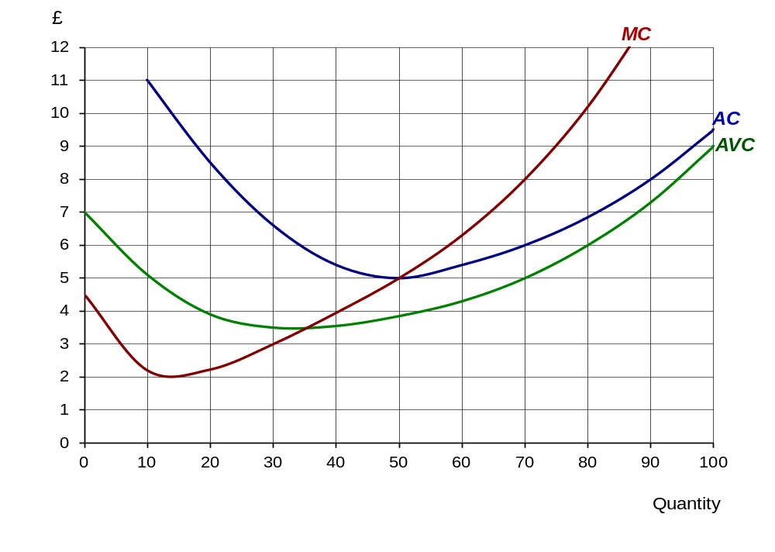The following diagram shows the cost curves of a firm under perfect competition.

  - How much will the firm produce to maximise profits at a price of £8 per unit?
  - What will be its average cost of production at this output?
  - How much (supernormal) profit will it make?
  - How much will the firm produce to maximise profits at a price of £5 per unit?
  - How much (supernormal) profit will it make?
  - How much will the firm produce to maximise profits at a price of £4 per unit?
  - What will be its profit position now?
  - Below what price would the firm shut down in the short run?
  - Below what price would the firm shut down in the long run?

- A monopolist is faced with the following cost and revenue curves:
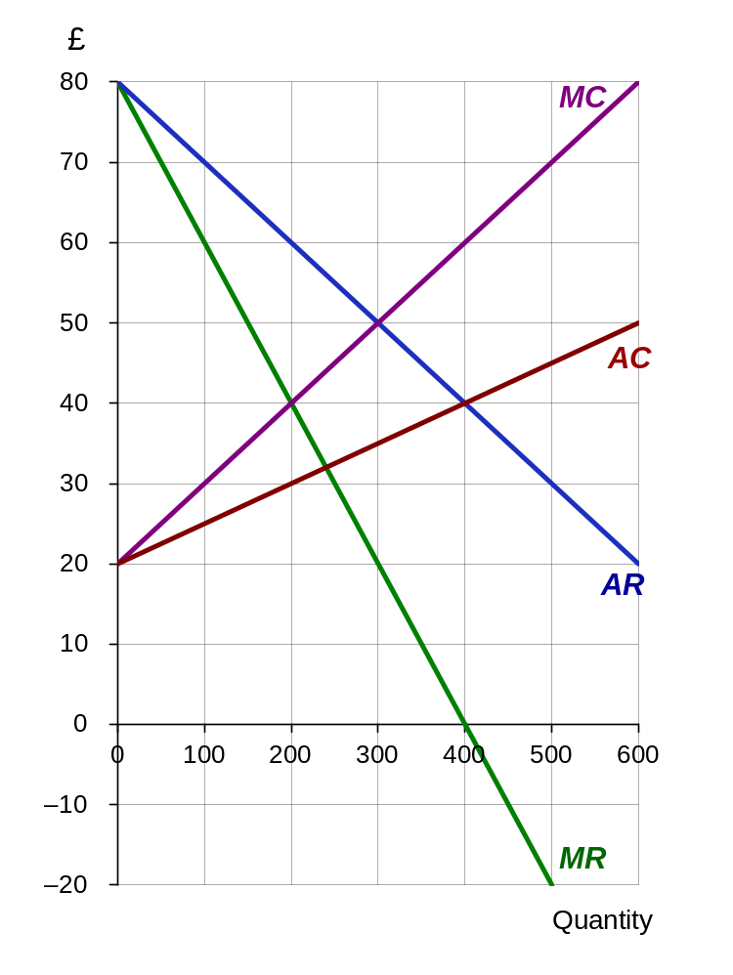
  - What is the maximum-profit output?
  - What is the maximum-profit price?
  - What is the total revenue at this price and output?
  - What is the total cost at this price and output?
  - What is the level of profit at this price and output?
  - If the monopolist were ordered to produce 300 units, what would happen to the market price?
  - Why might a regulator order the firm to increase output to this level?
  - How much profit would the firm make?.
  - Assume now that the monopolist decides not to maximise profits, but instead sets a price of £40. How much will now be sold?
  - What is the marginal revenue at this output?
  - What does the answer to (l) indicate about total revenue at a price of £40?
  - What is the price elasticity of demand at a price of £40? (You do not need to do a calculation to work this out: think about the relationship between MR and TR.)
Sample exam questions
4. Applying the structure-conduct-performance approach, what might we conclude about the likely structure of an industry, such as motor vehicle manufacturing in which there are substantial economies of scale?

5. There is some debate as to whether Google is considered to hold a monopoly in the market for internet search engines. Describe the changes Google would face if it lost any monopoly power it held, due to two strong competitors entering the market.

Supplementary questions (will not be discussed in class)
6. In which of the four categories would you place each of the following? (It is possible in some cases that part of the industry could be in one category and part in another: if so name both.)
  - A village post office
  - Restaurants in a large town
  - Banks
  - Games console manufacturers
  - Producers of barley
  - Water supply
  - Local buses
  - The market for foreign currency

7. What is wrong with the following claim? A monopolist can choose how much to sell and at what price.

